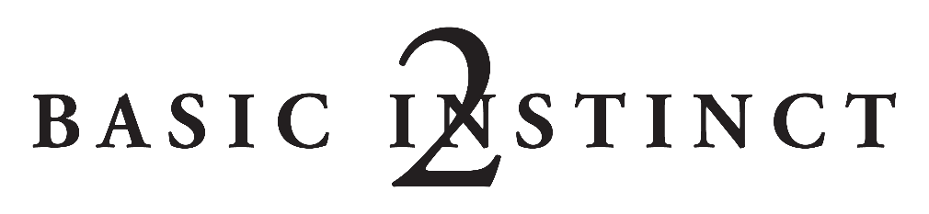
CAPTIONS
BI2-059 — Sharon Stone stars in Mario F. Kassar and Andrew G. Vajna's psychological thriller BASIC INSTINCT 2, from Metro-Goldwyn-Mayer Pictures and Sony Pictures Releasing. Photo by: Jaap Buitendijk

BI2-065 — Sharon Stone stars in Mario F. Kassar and Andrew G. Vajna's psychological thriller BASIC INSTINCT 2, from Metro-Goldwyn-Mayer Pictures and Sony Pictures Releasing. Photo by: Jaap Buitendijk

BI2-068 — Sharon Stone stars in Mario F. Kassar and Andrew G. Vajna's psychological thriller BASIC INSTINCT 2, from Metro-Goldwyn-Mayer Pictures and Sony Pictures Releasing. Photo by: Jaap Buitendijk

BI2-078 — Sharon Stone stars in Mario F. Kassar and Andrew G. Vajna's psychological thriller BASIC INSTINCT 2, from Metro-Goldwyn-Mayer Pictures and Sony Pictures Releasing. Photo by: Bill Kaye

BI2-098 — David Morrissey stars in Mario F. Kassar and Andrew G. Vajna's psychological thriller BASIC INSTINCT 2, from Metro-Goldwyn-Mayer Pictures and Sony Pictures Releasing. Photo by: Jaap Buitendijk

BI2-126 — David Morrissey stars in Mario F. Kassar and Andrew G. Vajna's psychological thriller BASIC INSTINCT 2, from Metro-Goldwyn-Mayer Pictures and Sony Pictures Releasing. Photo by: Jaap Buitendijk

BI2-188 – Sharon Stone (l) and David Morrissey star in Mario F. Kassar and Andrew G. Vajna's psychological thriller BASIC INSTINCT 2, from Metro-Goldwyn-Mayer Pictures and Sony Pictures Releasing.
Photo by: Jaap Buitendijk

BI2-199 — David Morrissey (l) and Sharon Stone star in Mario F. Kassar and Andrew G. Vajna's psychological thriller BASIC INSTINCT 2, from Metro-Goldwyn-Mayer Pictures and Sony Pictures Releasing.
Photo by: Jaap Buitendijk

BI2-219 - Sharon Stone (l) and Charlotte Rampling star in Mario F. Kassar and Andrew G. Vajna's psychological thriller BASIC INSTINCT 2, from Metro-Goldwyn-Mayer Pictures and Sony Pictures Releasing.
Photo by: Jaap Buitendijk

BI2-230 — Terence Harvey (l) and Sharon Stone star in Mario F. Kassar and Andrew G. Vajna's psychological thriller BASIC INSTINCT 2, from Metro-Goldwyn-Mayer Pictures and Sony Pictures Releasing.
Photo by: Jaap Buitendijk

BI2-241 — David Thewlis (l) and David Morrissey star in Mario F. Kassar and Andrew G. Vajna's psychological thriller BASIC INSTINCT 2, from Metro-Goldwyn-Mayer Pictures and Sony Pictures Releasing.
Photo by: Jaap Buitendijk

BI2-250 - David Thewlis (l) and David Morrissey star in Mario F. Kassar and Andrew G. Vajna's psychological thriller BASIC INSTINCT 2, from Metro-Goldwyn-Mayer Pictures and Sony Pictures Releasing.
Photo by: Jaap Buitendijk

BI2-311 — Director Michael Caton-Jones (l) and Sharon Stone on the set of Mario F. Kassar and Andrew G. Vajna's psychological thriller BASIC INSTINCT 2, from Metro-Goldwyn-Mayer Pictures and Sony Pictures Releasing.
Photo by: Jaap Buitendijk

BI2-334 – (l to r) Producer Mario Kassar, Sharon Stone and director Michael Caton-Jones on the set of Mario F. Kassar and Andrew G. Vajna's psychological thriller BASIC INSTINCT 2, from Metro-Goldwyn-Mayer Pictures and Sony Pictures Releasing. Photo by: Jaap Buitendijk

BI2-362 – Sharon Stone (l) and producer Mario Kassar on the set of Mario F. Kassar and Andrew G. Vajna's psychological thriller BASIC INSTINCT 2, from Metro-Goldwyn-Mayer Pictures and Sony Pictures Releasing.
Photo by: Jaap Buitendijk

Basic Instinct 2 has been rated R by the Motion Picture Association of America for Strong Sexuality, Nudity, Violence, Language and Some Drug Content.

